**Docker Desktop's Kubernetes Setup and Installation - Windows**

*2-22-2021*

These instructions are for using Docker Desktop's built-in Kubernetes instead of Minikube on Windows. **This is currently the best-supported and most recommended solution for running Kubernetes on Windows.**

*Note - It is assumed that Docker Desktop has already been installed and is in a working state.*

1. Click the **upward-facing** **arrow** on the right side of the Windows System Tray, then click the **Docker icon**.

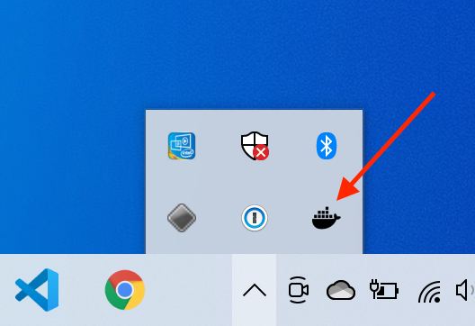

1. Click the **Gear icon** in the top menu bar of the Docker Desktop application.

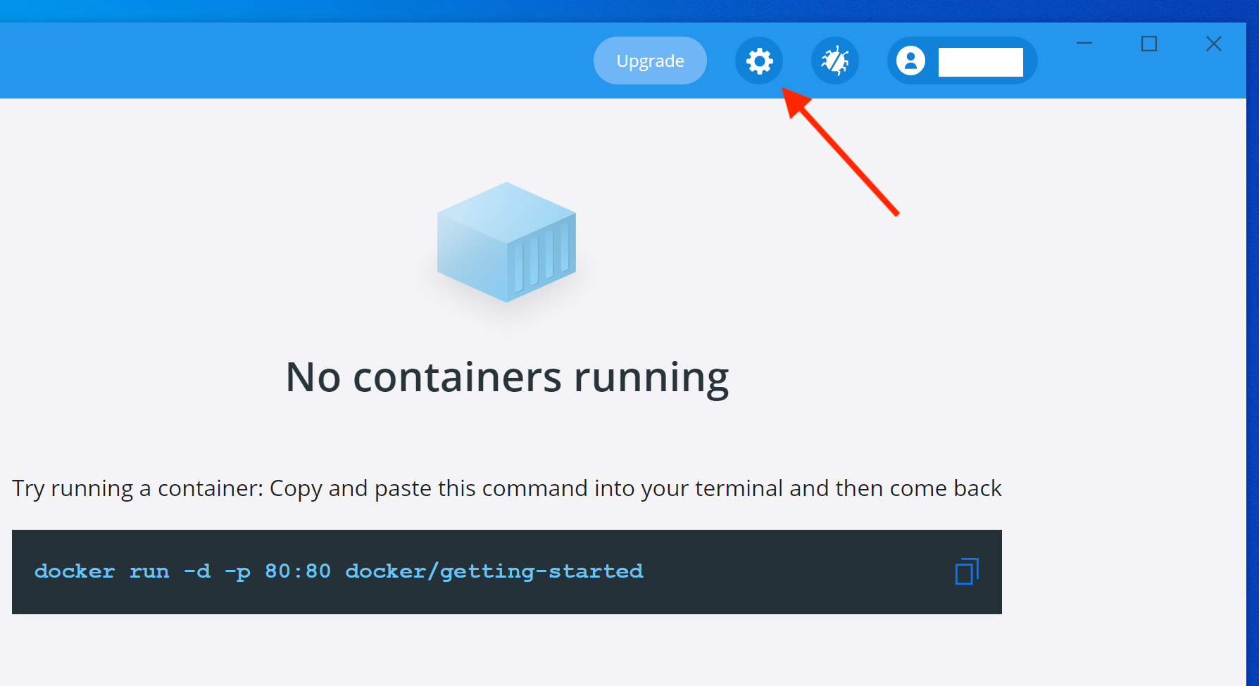

1. In the **General** settings section, make sure that the **Use WSL 2 based engine box** is checked. This assumes that WSL2 is supported by your OS and has already been installed and enabled. If not, please see the WSL2 setup instructions [here](https://docs.microsoft.com/en-us/windows/wsl/install-win10).

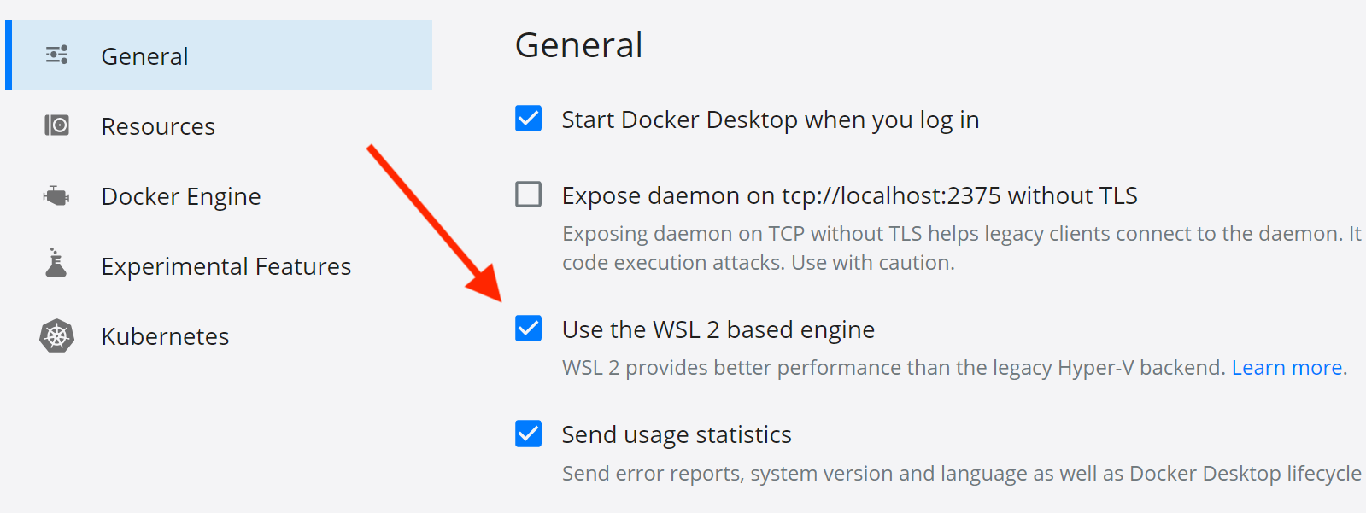

1. Click **Kubernetes** in the left side menu.

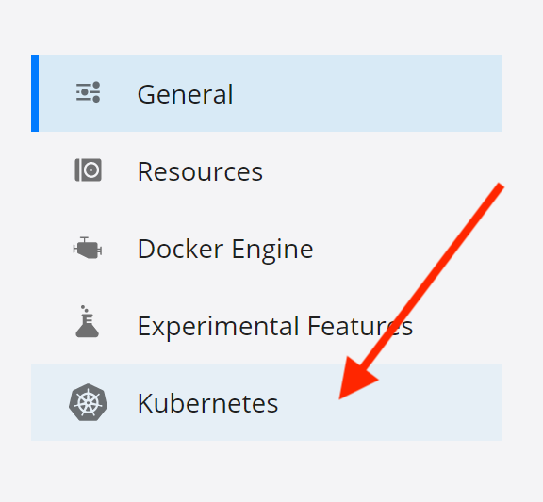

1. Check the **Enable Kubernetes** box and then click the **Apply & Restart**button**.**

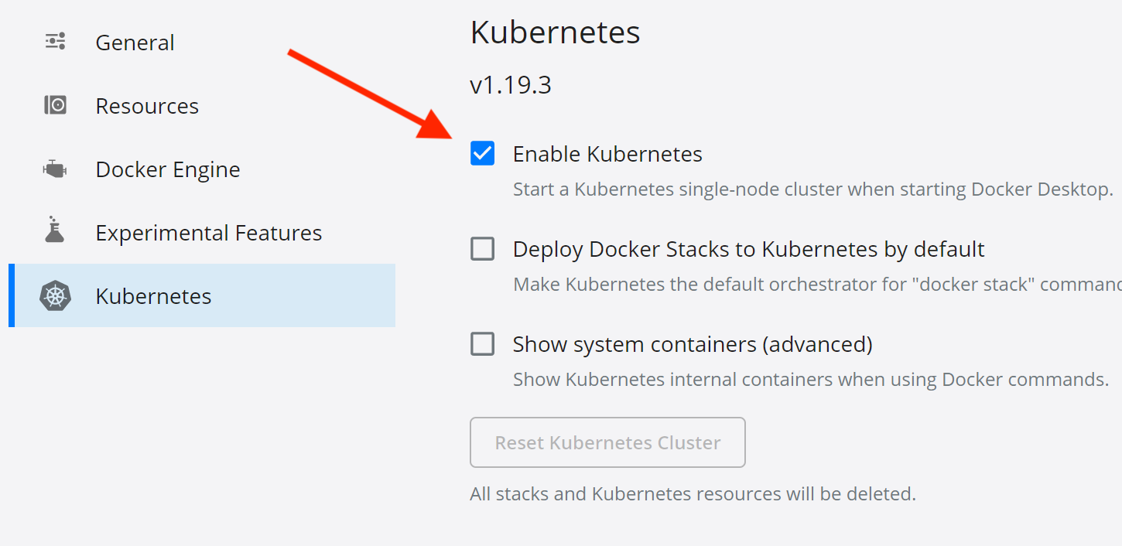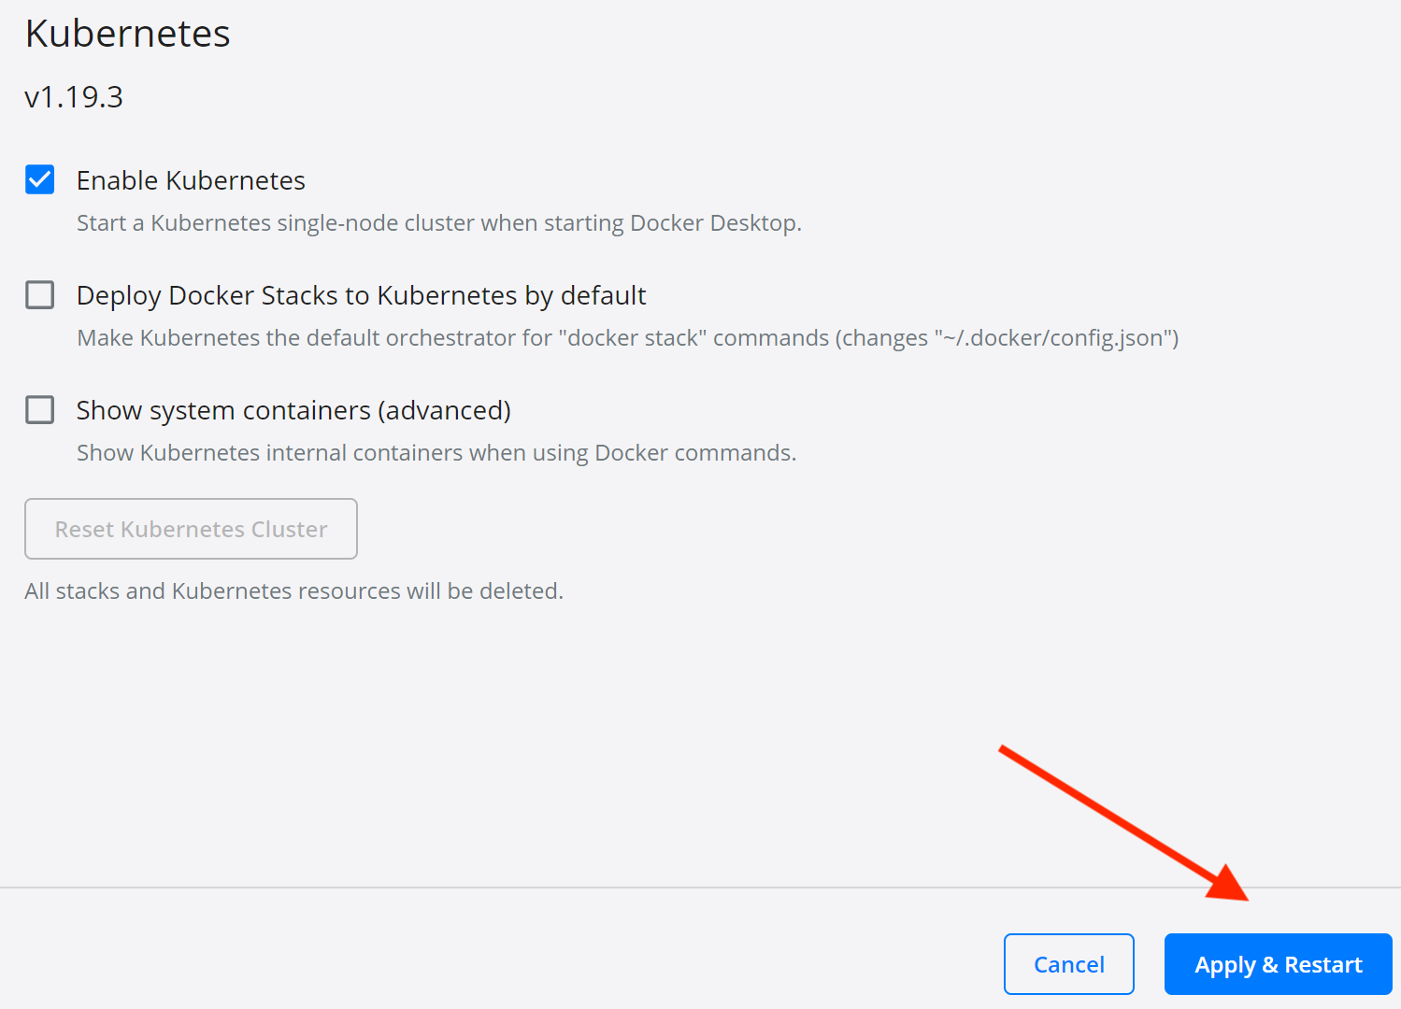

1. Click **Install** to allow the cluster installation.

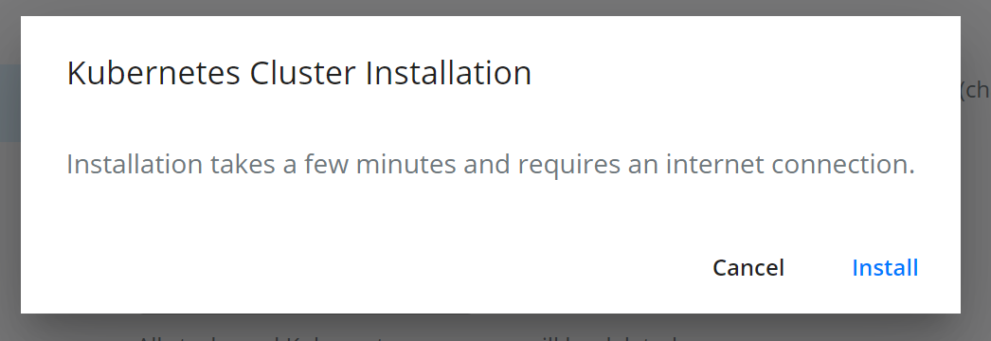

1. After the installation dialog disappears, look at the bottom left side of the **General** Settings page and make sure there is a **green Kubernetes icon**. If you click it, it should display a **RUNNING** tooltip.

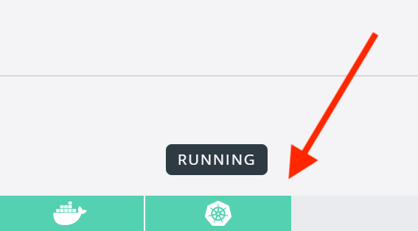

1. Finally, open up your terminal of choice and make sure that you can run kubectl version

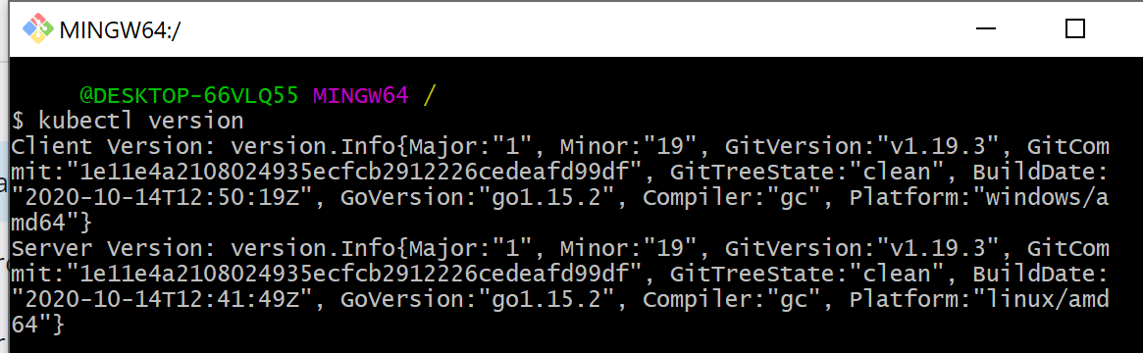

*Note - the client and server can be off by one minor version without error or issue.*

**Usage**

Going forward, any minikube commands run in the lecture videos can be ignored. Also, you will be using **localhost** to access the services running in your cluster instead of the minikube IP address.

For example, in the first project where we deploy our simple React app, using minikube we would visit:

192.168.99.101:31515

Instead, when using Docker Desktop's Kubernetes, we would visit:**localhost:31515**